

**Liability Release Form**

Neither the school nor the instructors will be liable for any personal injury incurred during any dance class, rehearsal, performance, or other camp activities.

(The school is not responsible for lost or stolen belongings, therefore, please be sure to label all children’s items)

**As parent/guardian of my child,**

______________________________,

(Please Print Name of Student)

**I have read this release of liability and assumption of risk agreement, and fully understand its terms.**

______________________________

(Parent/guardian signature)

*______________*

(Date)





**1501 Sieveright Road, Unit #8  
Ottawa ON K1T 1M5   
(613) 730-3066**www.vanessaplettelldance.ca

# **SUMMER DANCE PROGRAMS 2021**

**Camps for Ages 3 to 14**

Summer Camp Weeks

WEEK 1: July 5 to July 9, 2021  
WEEK 2: July 12, to July 16, 2021

**Different theme each week!**

**Summer Dance Programs 2021 Registration Form**

|  |  |  |  |  |  |  |
| --- | --- | --- | --- | --- | --- | --- |
| **Student Information** | | | | | | |
| **First Name** | | | | | | |
| **Last Name** | | | **Male** | | | **Female** |
| **Date of Birth (Month, Day, Year)** | | | | | | **Age** |
| **Address** | | | **Phone** | | | |
| **Please circle week(s) you are registering for:**  **Week 1 Week 2** | | |  | | | |
| Parent and Emergency Contact Information | | | | | | |
| **Parent’s Name:** |  | | | | | |
| **Phone** | H: | W: | | | C: | |
| **Email** |  | | | | | |
| **Emergency  Contact Name 1:** |  | | | | | |
| **Phone:** | H: | W: | | | C: | |
| **Emergency  Contact Name 2:** |  | | | | | |
| **Phone:** | H: | W: | | C: | | |
| **Health Card #** | | | | | | |
| **Please indicate any injuries or health problem we should be aware of:** | | | | | | |
| To ensure your child place in the program, please return registration form, with full payment, as soon as possible. Registrations: Vanessa Plettell Dance reserves the right to cancel the summer dance program due to insufficient registration. Please call Vanessa Plettell Dance in the event that you have not registered prior to the start of classes and plan on attending. **Please make cheques payable to Vanessa Plettell Dance Inc. Cash, Debit, Visa, and MasterCard are also accepted.** | | | | | | |

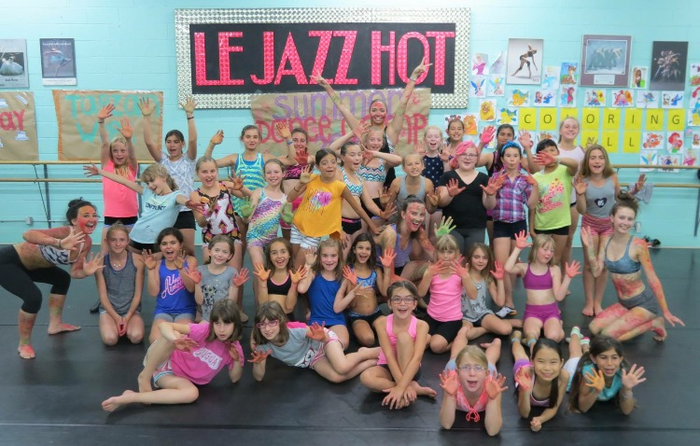

**3 Dance Programs Offered!**

Tiny Dancers: Full day program for children aged 3-5   
Fun Dancers: Full day program for children aged 6-14  
Intensive Dancers: Full day program for children aged 8-14

**Our dance programs include:** Ballet, Jazz, Stretch and Conditioning, Hip Hop, Contemporary/Lyrical, Musical Theatre

**End of the week in-house show each week:**Week 1: July 5 to July 9, 2021   
Week 2: July 12 to July 16, 2021  
  
Full Day Program: 9am to 4pm

All children in any program should bring a snack and a water bottle daily. Children in the full program need to bring a lunch. PEANUT FREE FACILITY.

**Dress Code**: Bodysuit, tights, or shorts and t-shirt. Ballet, Jazz, Gymnastics slippers, socks or bare feet. *Be sure to label all of your child’s items*

**Prices**

1 week/5 days $260.00 (full day)  
  
2 weeks/ 10 days $490.00 (full day)  
  
All fees include all materials/arts and crafts per week, and guest teachers.  
Additional fees, if applicable: pizza lunch and fun activity of the week.   
  
Before and after care (8am to 9am & 4pm to 5pm) additional charge of $25.00